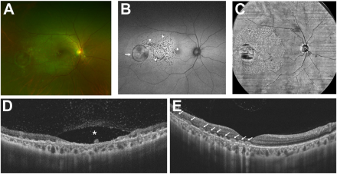

A 35-year-old man presented with reduced vision in the right eye to 20/100 after being infected with Klebsiella pneumonia 2 weekspreviously. The right fundus showed one circular and several punctate lesions (A). Both types of lesions were hypoautofluorescent (B,arrow and arrowheads). Structural en face OCT showed a larger lesion area (C). The circular and punctate lesions showed atrophy of theretina (D, asterisks) and discontinuity in the retinal pigment epithelium layer with hyperreflective foci (E, arrow) and overlying vitritis onOCT. Treatment with systemic antimicrobials and glucocorticoids abated the retinitis by 1 month, but his vision remained 20/100. Based on the provided images and clinical description please make an ophthalmic diagnosis for this patient. And output the diagnostic conclusions only

**Endogenous Klebsiella endophthalmitis**